# Bahria University,

## Karachi Campus



LAB EXPERIMENT NO.

**_06_**

LIST OF TASKS

|  |  |
| --- | --- |
| **TASK NO** | **OBJECTIVE** |
| 01 | Design and implement a web service that provides currency conversion functionality. The web service should accept requests to convert an amount from one currency to another and return the converted amount. |
| 02 | Design and implement a web service that provides scientific calculator functionality over the internet. The web service should allow users to perform various mathematical operations, including basic arithmetic, trigonometric functions, logarithms, and more. |
|  |  |
|  |  |
|  |  |
|  |  |
|  |  |
|  |  |
|  |  |

Submitted On:

Date: 28/03/2024

**Task No 01:** Design and implement a web service that provides currency conversion functionality. The web service should accept requests to convert an amount from one currency to another and return the converted amount.

**Solution:**

public class WebService1 : System.Web.Services.WebService

{

[WebMethod]

public double CurrencyConversion(double amount, string fromCurrency, string toCurrency)

{

Dictionary<string, double> conversionRates = new Dictionary<string, double>{

{ "USD", 1.0 },

{ "EUR", 0.85 },

{ "GBP", 0.73 },

{ "JPY", 109.92 },

{ "PKR",270 },};

double convertedAmount = amount * (conversionRates[toCurrency] / conversionRates[fromCurrency]);

return convertedAmount;}}

**Output:**

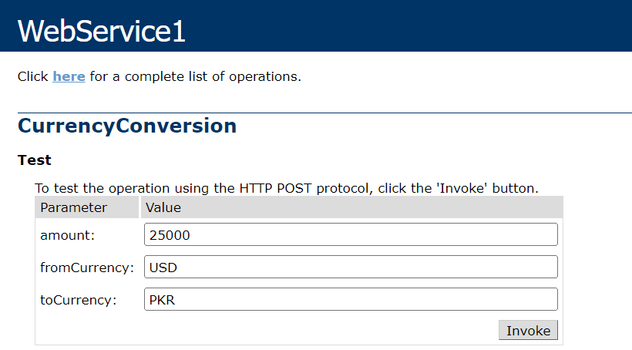

**Task No 02:** Design and implement a web service that provides scientific calculator functionality over the internet. The web service should allow users to perform various mathematical operations, including basic arithmetic, trigonometric functions, logarithms, and more.

**Solution:**

public class WebService1 : System.Web.Services.WebService{

[WebMethod]

public double Add(double num1, double num2){

return num1 + num2;}

[WebMethod]

public double Subtract(double num1, double num2){

return num1 - num2;}

[WebMethod]

public double Multiply(double num1, double num2){

return num1 * num2;}

[WebMethod]

public double Divide(double num1, double num2){

if (num2 == 0){

throw new DivideByZeroException("Cannot divide by zero.");}

return num1 / num2;}

[WebMethod]

public double Sin(double angle){

return Math.Sin(angle);}

[WebMethod]

public double Cos(double angle){

return Math.Cos(angle);}

[WebMethod]

public double Tan(double angle){

return Math.Tan(angle);}

[WebMethod]

public double Log(double num){

return Math.Log(num);}}

**Output:**

**

